TRADING THE LAST KISS

The last-kiss trade is a nice way to trade high-probability breakout trades. Here are the steps for the last-kiss trade:
Wait for price to consolidate in a box between two zones. The box should have at least two touches on both zones.
Wait for price to break beyond one of the zones.
Once price returns back to the consolidation box, wait for the market to print a last-kiss candlestick on the edge of the box.
For sell trades, a sell stop is placed below the low of the last-kiss candlestick, and for buy trades, a buy stop is placed above the high of the last-kiss candlestick. Emergency stop loss is placed in the midpoint of the consolidation box. The profit target is the nearest zone.
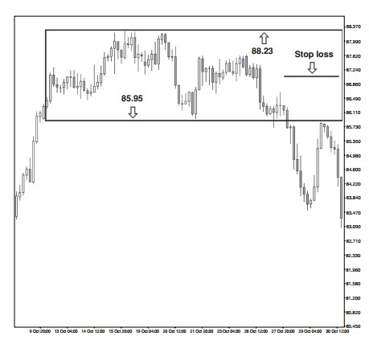

Engulfing Candlestick / Big Shadow
Big shadows are two-candlestick formations.
The second candlestick of the formation is the big-shadow candlestick.
The big-shadow candlestick has a higher high and a lower low than the previous candlestick.
Big shadows must print on the zones.
Big shadows print at extreme highs or extreme lows.
Bearish big-shadow candlesticks have a closing price near the low.
Bullish big-shadow candlesticks have a closing price near the high.
Big-shadow candlesticks have wider ranges than the nearby candlesticks.
For bullish big shadows, the stop loss is placed a few pips below the low of the big-shadow candlestick. For bearish big shadows, the stop loss is placed a few pips above the high of the big-shadow candlestick.
The very best big-shadow candlesticks have room to the left.
There are also several optimal characteristics that the best big shadows share; these features include:
The two-candlestick formation prints at an extreme high or low on the chart where the market has not traded in at least seven candlesticks.
The big-shadow candlestick has a greater range than the previous 10 candlesticks.
For bullish big shadows, the candlestick following the bullish big shadow triggers the buy stop order placed above the high of the big-shadow candlestick.
For bearish big shadows, the candlestick following the bearish big shadow triggers the sell stop order placed below the low of the bigshadow candlestick.
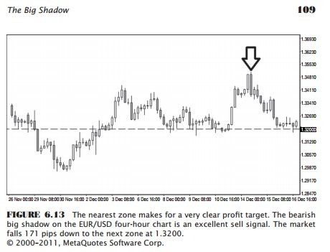
For bullish big shadows, the closing price for the big-shadow candlestick is within a few pips of the high. Opposite for bearish shit.

Double Top/Bottom – “Wammie / Moolah” (stupid names)
These are the seven important characteristics of the wammie pattern (reverse for moolah).
1. The market touches the support zone twice.
2. The second touch is higher than the first touch.
3. There are at least six candlesticks between touches
4. The market prints a bullish candlestick on the second touch.
5. The trade is entered with a buy stop a few pips above the bullish candlestick.
6. The stop loss is placed a few pips below the first (lower) touch.
7. The profit target is the next zone above the wammie.

If you want to pick only the very best wammies and moolahs, try to do the following:
Choose the set-ups with many candlesticks between touches.
Six candlesticks between touches is nice to see, but 20 candlesticks between touches is better.
Take trades with catalysts on the second touch.
If the second touch is a big shadow or a kangaroo tail, the odds are probably strongly in your favor.
Pick trades that have a second touch much further from the zone.
Only choose wammies and moolahs that are in strong, well-defined zones. If the zone is not an important one, then the market may only trade away from the zone briefly before breaking beyond the zone.
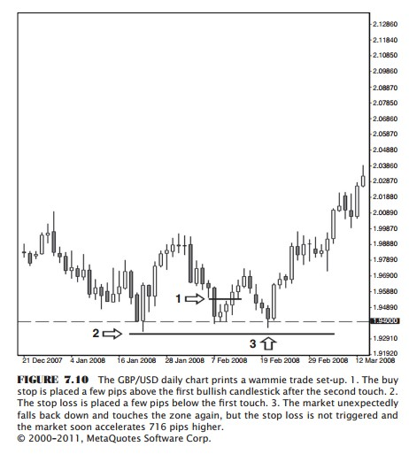
Major reversals often occur at places on the chart with very little price action to the left of the trade

KANGAROO-TAIL TIPS
If you have the patience to wait for only the very best kangaroo tails, watch for the following characteristics:
Kangaroo tails with a very long tails.
Kangaroo tails with much room to the left.
Bullish kangaroo tails with a closing price that is higher than the opening price.
The candlestick after the bullish kangaroo tail trades higher than the high of the kangaroo tail.
Bearish kangaroo tails with a closing price that is lower than the opening price.
The candlestick after the bearish kangaroo tail trades lower than the low of the kangaroo tail.
Kangaroo tails with a greater range than the previous 10 candlesticks.
Kangaroo tails that trigger the buy stop or sell stop entry on the first candlestick after the kangaroo tail.

There are also several red flags, so watch out for these:
Kangaroo tails with very short tails.
Kangaroo tails that do not print on a zone; these are not valid kangaroo tails.
Kangaroo tails preceded by giant candlesticks. This suggests that the trend may continue, and the kangaroo tail may only be a pause.
When the open and the close of the kangaroo tails are not contained by the range of the previous candlestick.
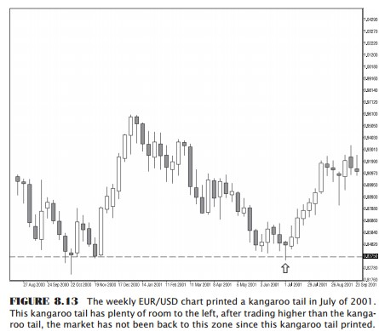

Big Belts (Big full candlesticks without wicks on either end)
Bullish (opposite for Bearish):
The opening price is near the candlestick low.
The closing price is near the candlestick high.
The big belt prints on an important zone.
The big belt should have room to the left.
The stop loss is placed below the candlestick low.
The buy stop is placed above the candlestick high.
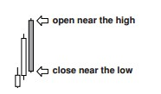
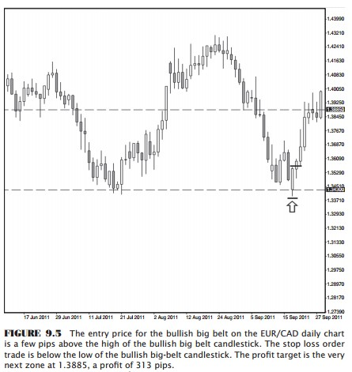
The closest zone is the profit target.
---> This is a Bearish belt ---------->

